Static Routing

Network Topology Diagram
This document describes the network topology consisting of four Cisco routers, four switches, and four PCs connected in a square routing topology.
The topology connects four routers in a square configuration allowing routing between four different LAN segments. Each router connects to a switch that serves a local PC. The LAN networks use the 192.168.x.x private addressing scheme while the router-to-router links use the 10.10.x.x addressing scheme. This topology uses static routing protocol.

Topology Diagram
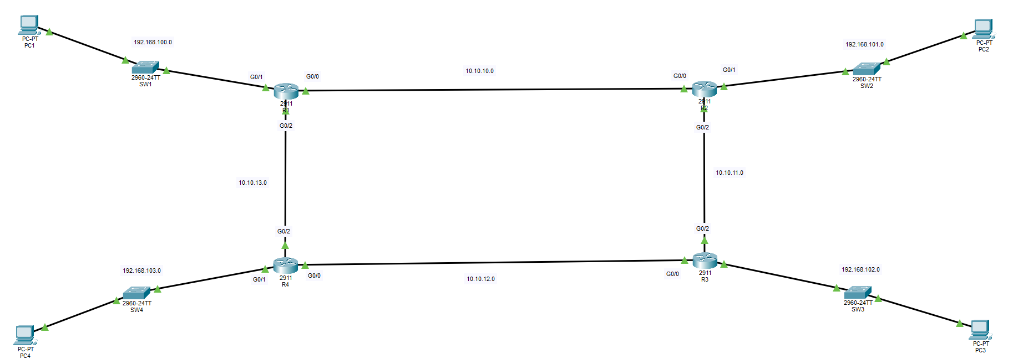

Devices
Routers: R1, R2, R3, R4
Switches: SW1, SW2, SW3, SW4
PCs: PC1, PC2, PC3, PC4

LAN Networks
Network | Connected Device
192.168.100.0 | PC1 LAN
192.168.101.0 | PC2 LAN
192.168.102.0 | PC3 LAN
192.168.103.0 | PC4 LAN

Router Interconnections
Link | Network
R1 ↔ R2 | 10.10.10.0
R2 ↔ R3 | 10.10.11.0
R3 ↔ R4 | 10.10.12.0
R4 ↔ R1 | 10.10.13.0

